Feedback Form:

Code:

<!DOCTYPE html>

<html lang="en">

<head>

    <meta charset="UTF-8">

    <meta name="viewport" content="width=device-width, initial-scale=1.0">

    <title>Feedback Form</title>

    <style>

        body {

            font-family: Arial, sans-serif;

            background: linear-gradient(to right, #007bff, #00c6ff);

            display: flex;

            justify-content: center;

            align-items: center;

            height: 100vh;

            margin: 0;

        }

        .container {

            background: #fff;

            padding: 20px;

            border-radius: 20px;

            box-shadow: 0 0 10px rgba(0, 0, 0, 0.1);

            width: 320px;

            text-align: center;

            border-radius: 20px;

            border-top-left-radius: 50px;

            border-top-right-radius: 50px;

        }

        label {

            font-weight: bold;

            display: block;

            margin-top: 10px;

            text-align: left;

        }

        input, select, textarea {

            width: 90%;

            padding: 8px;

            margin-top: 5px;

            border: 1px solid #ccc;

            border-radius: 10px;

            display: block;

            margin-left: auto;

            margin-right: auto;

            border-radius: 15px;

        }

        .submit-btn {

            background: #28a745;

            color: white;

            border: none;

            padding: 10px;

            margin-top: 10px;

            cursor: pointer;

            width: 100%;

            border-radius: 15px;

        }

        .submit-btn:hover {

            background: #218838;

        }

    </style>

</head>

<body>

    <div class="container">

        <h2>Feedback Form</h2>

        <form action="#" method="post">

            <label for="name">Name (Optional):</label>

            <input type="text" id="name" name="name" placeholder="Enter your name">

            <label for="email">Email (Optional):</label>

            <input type="email" id="email" name="email" placeholder="Enter your email">

            <label for="phone">Phone (Optional):</label>

            <input type="tel" id="phone" name="phone" placeholder="Enter your phone number">

            <label for="rating">Rating:</label>

            <select id="rating" name="rating" required>

                <option value="">Select Rating</option>

                <option value="1">1 - Poor</option>

                <option value="2">2 - Fair</option>

                <option value="3">3 - Good</option>

                <option value="4">4 - Very Good</option>

                <option value="5">5 - Excellent</option>

            </select>

            <label for="questions">Any Questions regarding product or service:</label>

            <textarea id="questions" name="questions" rows="4" required placeholder="Enter your questions here..."></textarea>

            <label for="comments">Additional Comments (Optional):</label>

            <textarea id="comments" name="comments" rows="3" placeholder="Enter any additional comments..."></textarea>

            <button type="submit" class="submit-btn">Submit</button>

        </form>

    </div>

</body>

</html>

Output:

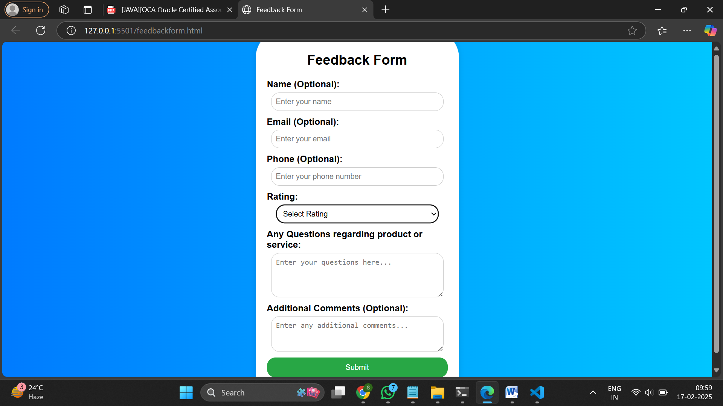

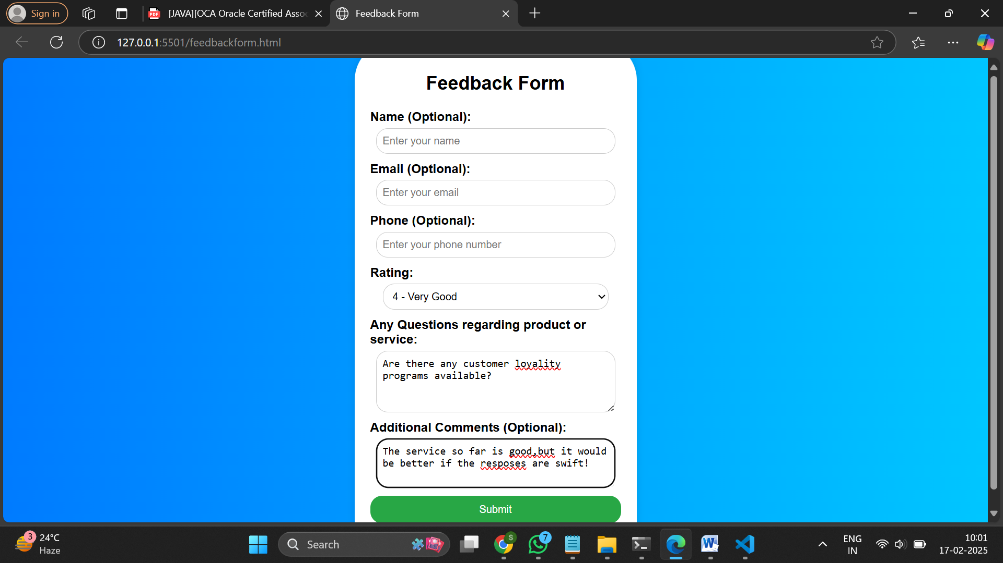

Githublink: <https://github.com/AjeersMyna/FEWD_LAB.git>

SandboxLINK: https://456qlx.csb.app/